EXPERIMENT NO:30

1. Design NFA to accept any number of a’s where input={a,b}.

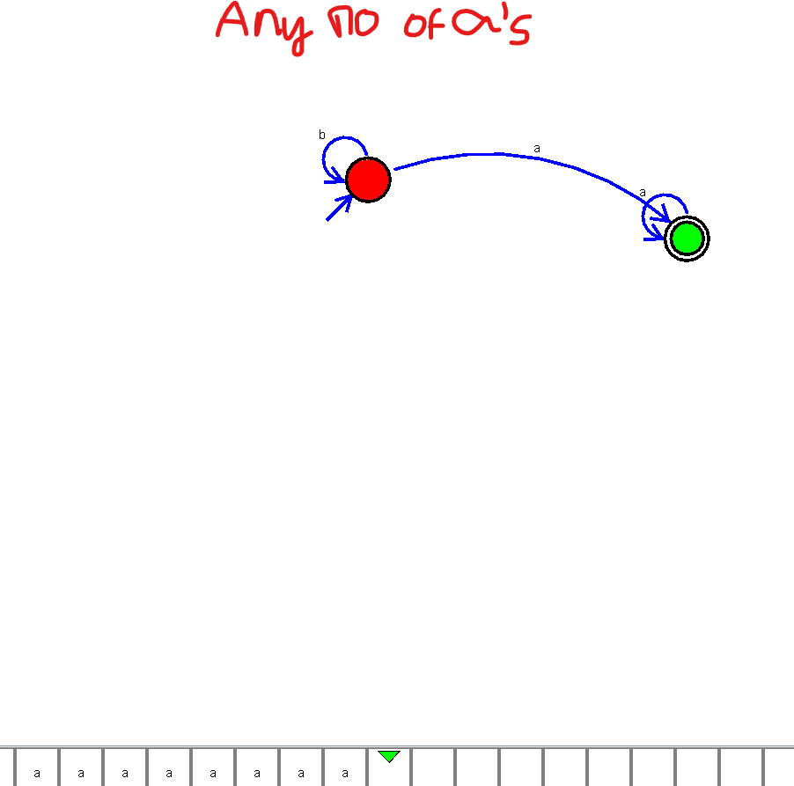

EXPERIMENT NO:36

1. Design NFA using simulator to accept the string the start with a and end with b over set {a,b} and check W= abaab is accepted or not.

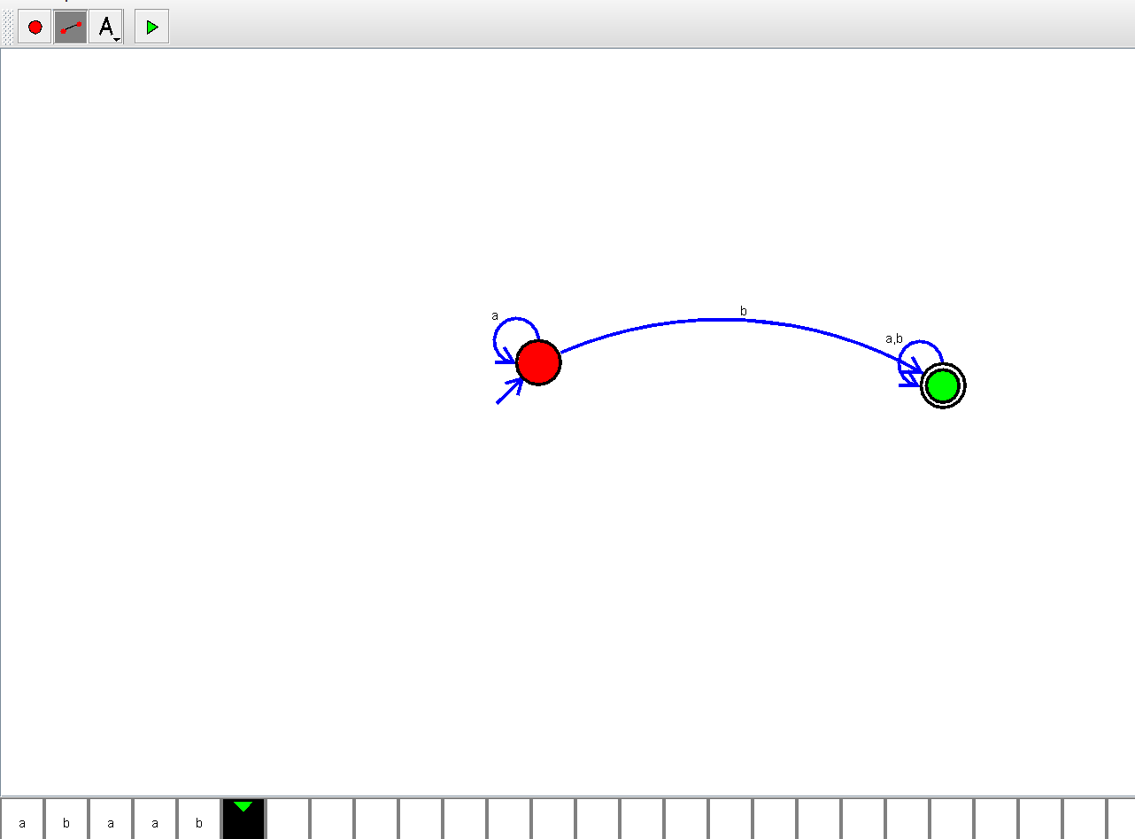

1. EXPERIMENT NO:37
2. Design NFA using simulator to accept the string that start and end with different symbols over the input {a,b}.

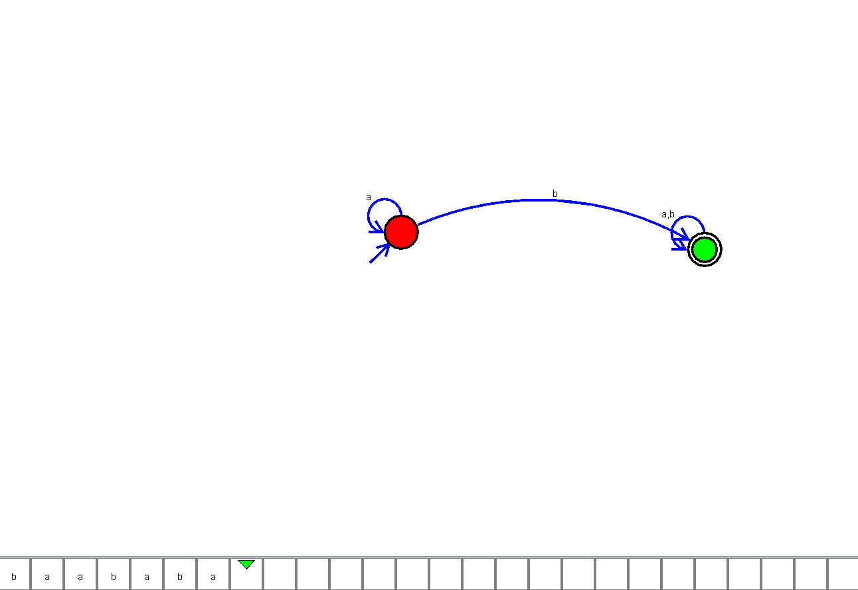

EXPERIMENT NO:38

1. Design NFA using simulator to accept the input string “bbc” ,”c”,and ”bcaaa”.

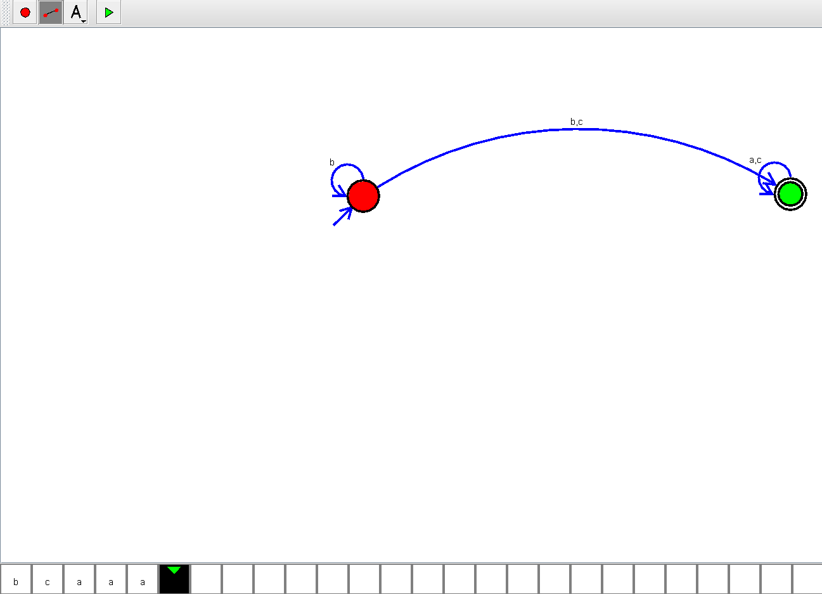

EXPERIMENT NO:40

1. Design NFA to accept any number of b’s where input={a,b}.

